**Advance DevOps lab**

**Experiment 4**

**Name: BALOCH MUZAMMIL HAFEEZ ROLL NO: 612012**

**Semester: V**

**Branch: Information Technology**

1. **What is NO SQL, Key value Databases?**

Ans: A key-value database is a form of non relational database that stores data using a simple key-value mechanism. A key-value database is a collection of key-value pairs in which the key serves as a unique identifier for the data. Keys and values can be any type of object, from simple objects to sophisticated compound things. Key-value databases are extremely partitionable and can scale horizontally to sizes that other types of databases cannot. Amazon DynamoDB, for example, creates additional partitions to a table when an existing partition reaches capacity and more storage space is necessary.

Amazon DynamoDB:

Amazon DynamoDB is a nonrelational database that performs consistently at any scale. It's a fully managed, multi-region, multi-master database that offers built-in security, backup and restore, and in-memory caching, as well as consistent single-digit millisecond latency. An Item in DynamoDB is made up of a main or composite key and a variable number of attributes. There is no stated limit on the amount of attributes that can be connected with a single item, however the total size of an item, including all attribute names and values, cannot exceed 400 KB. A table is a collection of data elements, just as a row is a collection of rows in a relational database. There is no limit to the number of data elements that can be stored in a table.

1. **Create a Table in DynamoDB , Add items to the table (minimum 10 items) , Query the table .**

Step 1: Management Console Dashboard.

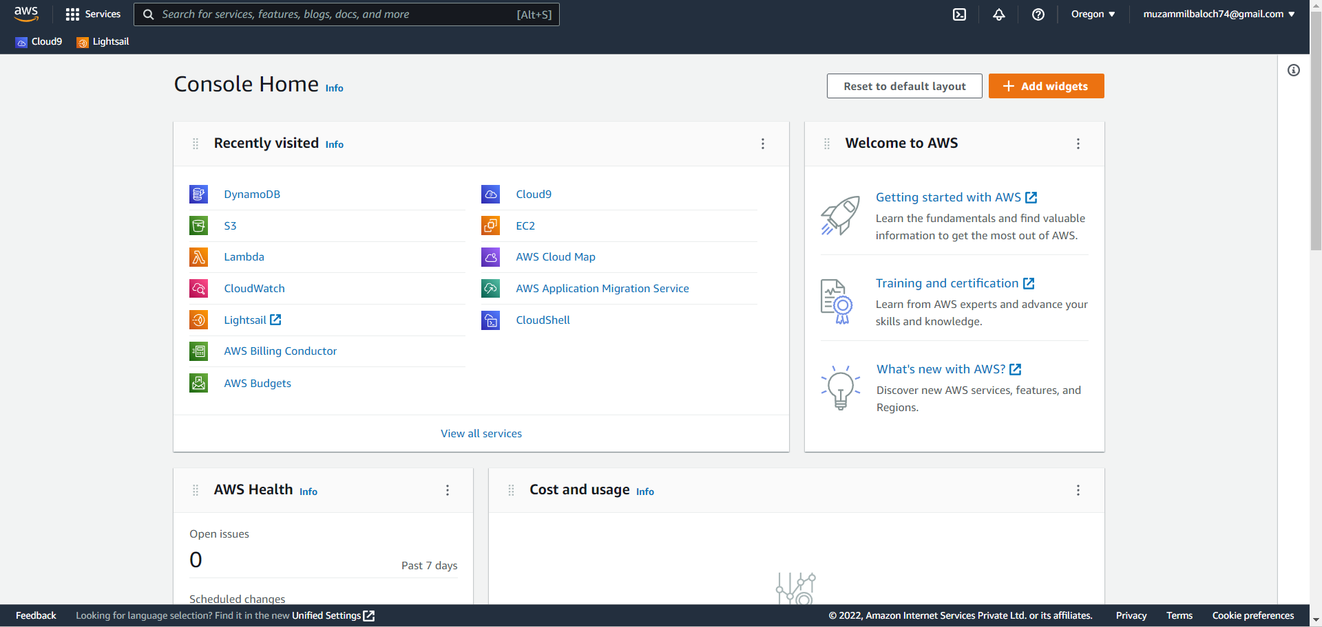

Step 2: Click on services and then click on DynamoDB.

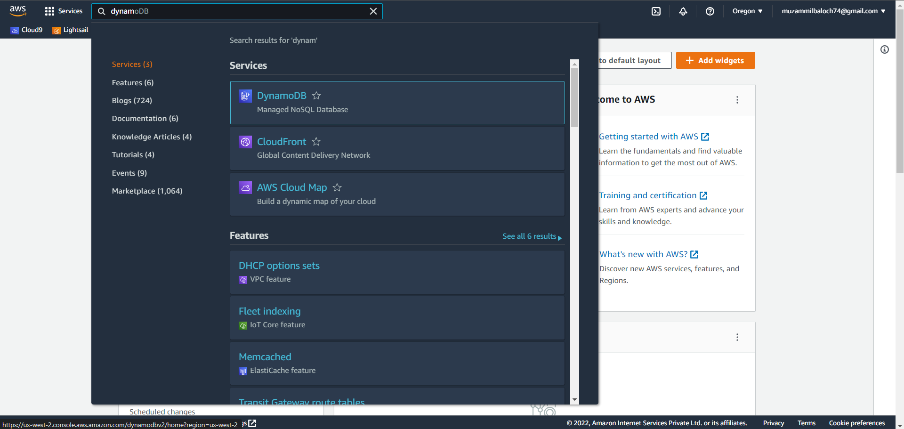

Step 3: Create a table.

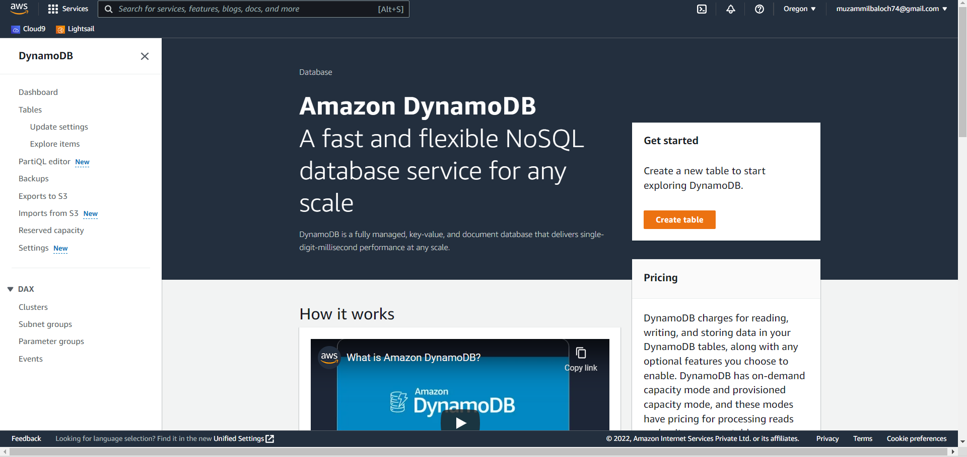

Step 4: Name the table.

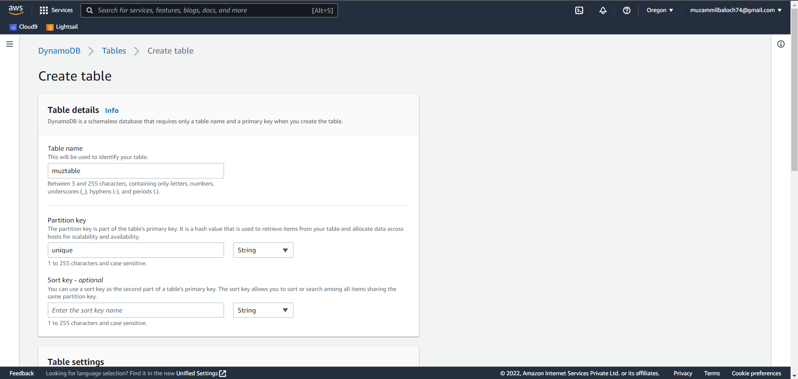

Step 5: Review the settings and create the table.

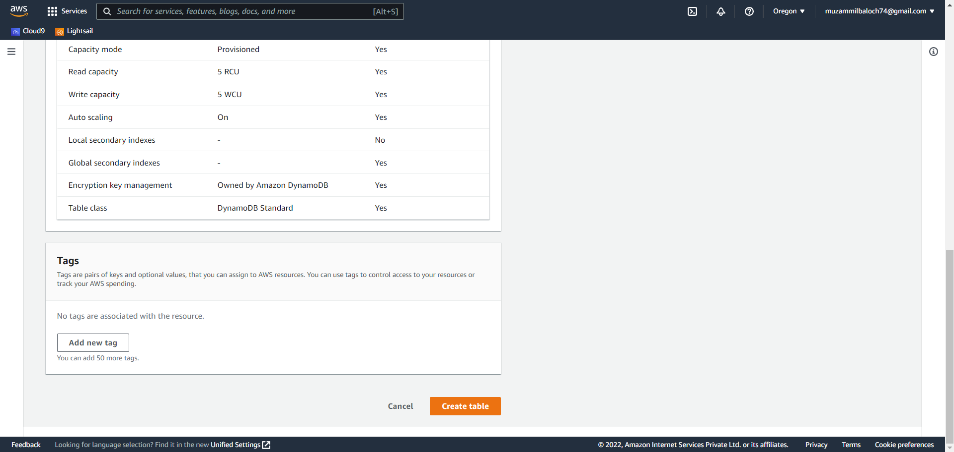

Step 6: select the table you have created.

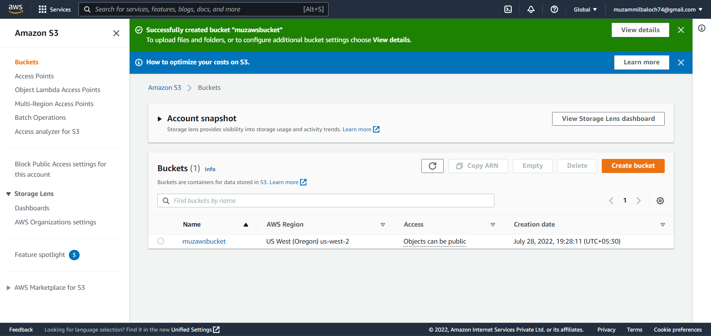

Step 7: Add items in the table.

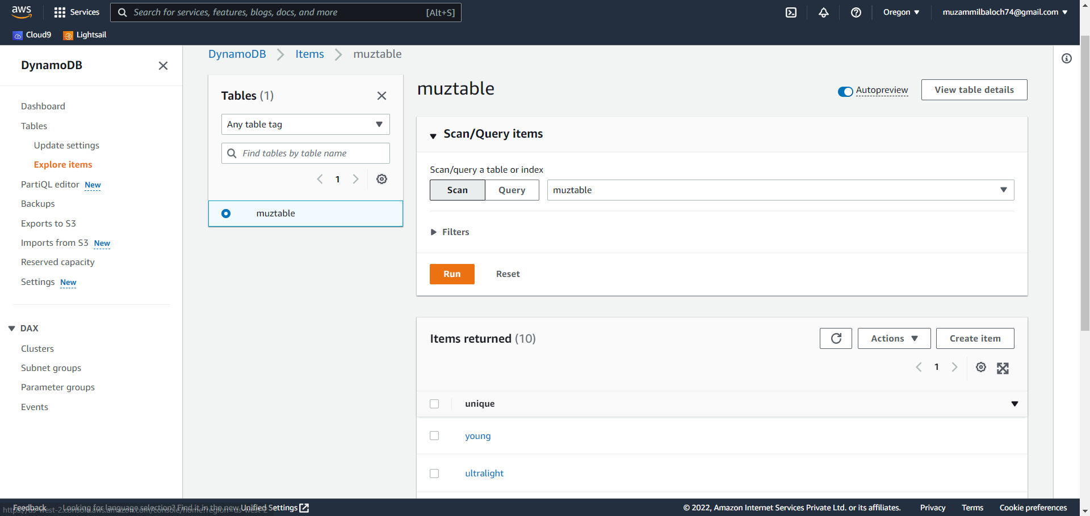

Step 8: After creating 10 items search for a query.

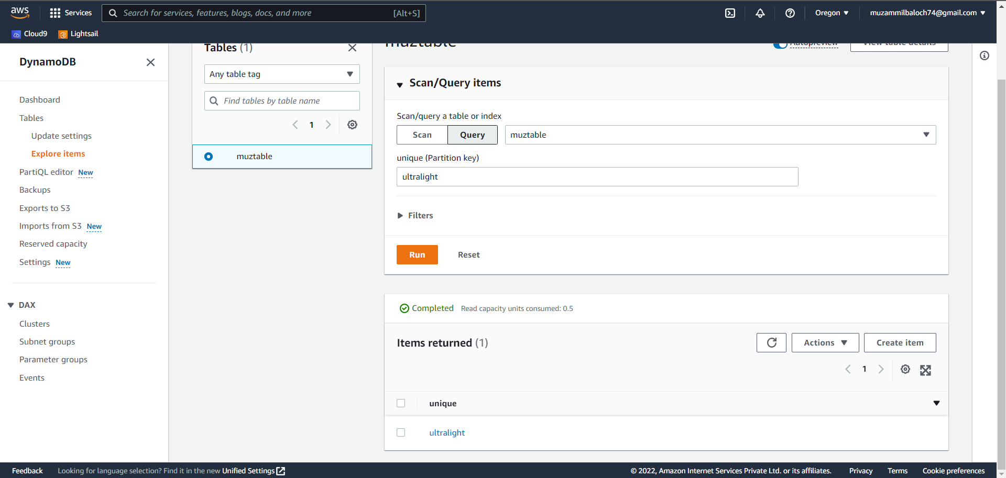

Step 9: Delete the table.

